1. **Generate blog topic ideas on : how to start with django for e-commerce store\n \n 1.**

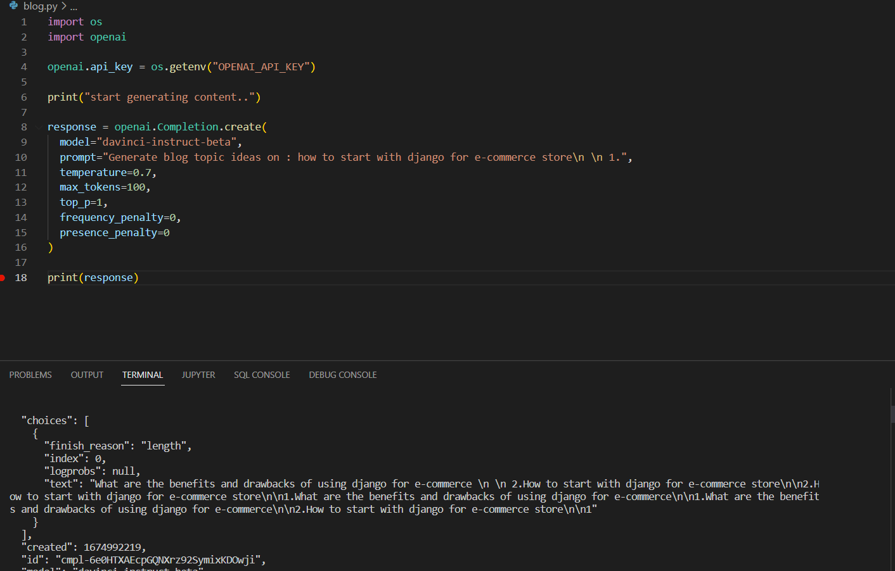

1. Generate blog topic ideas on : how to start with reactjs for e-commerce store\n \n 1.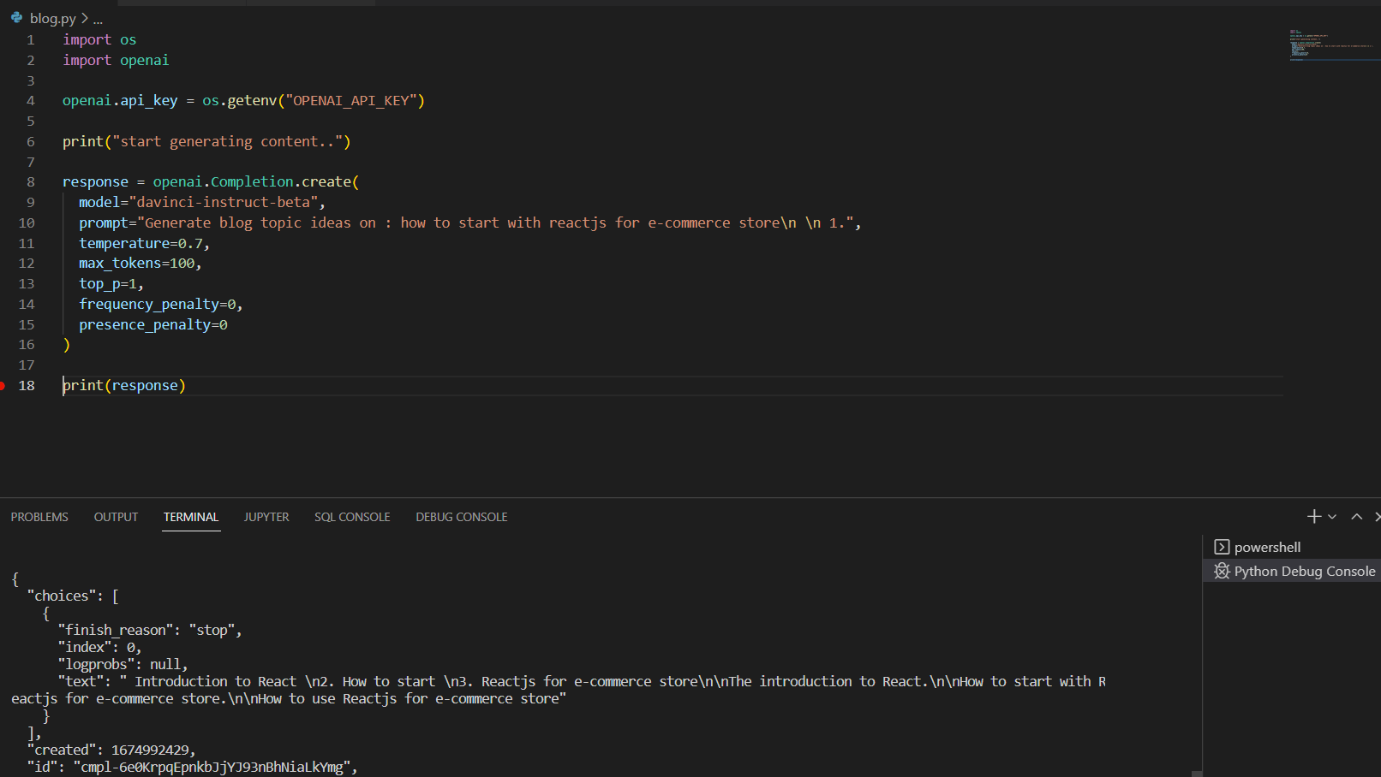
2. Generate blog topic ideas on : how to make a application for e-commerce store\n \n 1.

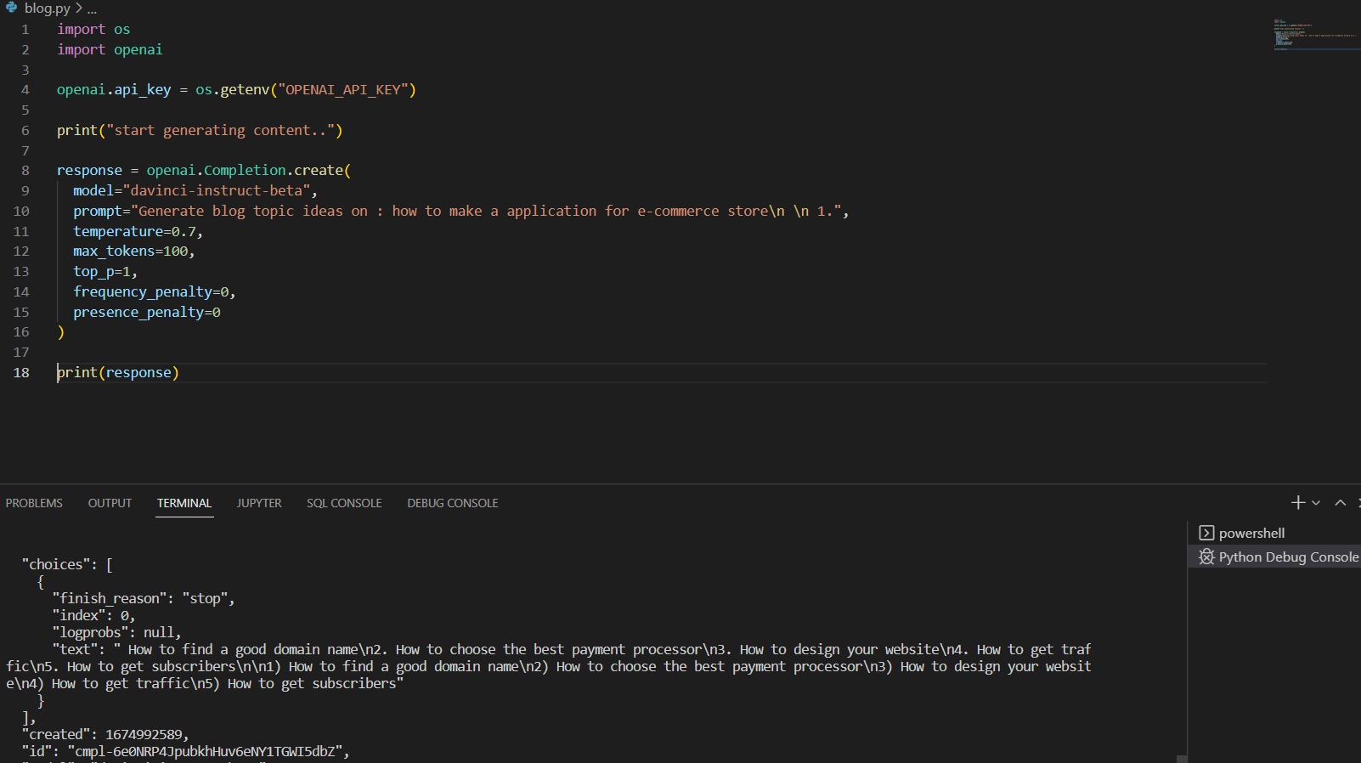

================ * Ai based blog content generator tool * ==================

1. Find a blog topic you want to write about

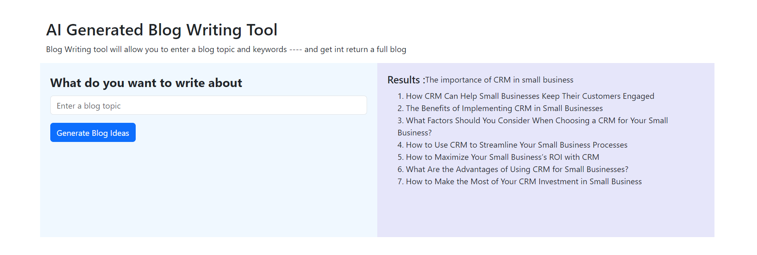

1. Generate a blog section from the blog title you choose

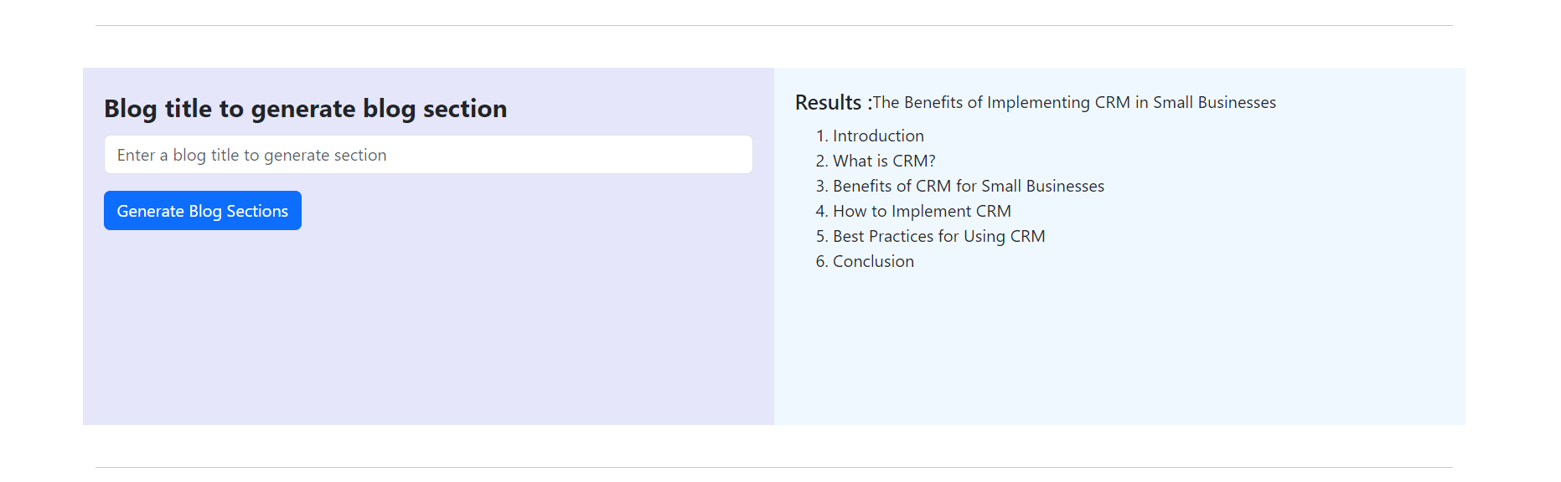

1. Generate content for the section you choose:

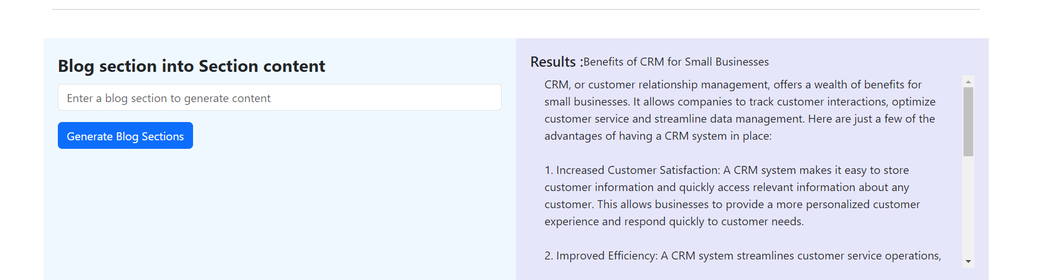

Another example:-

1. Generate blog ideas:

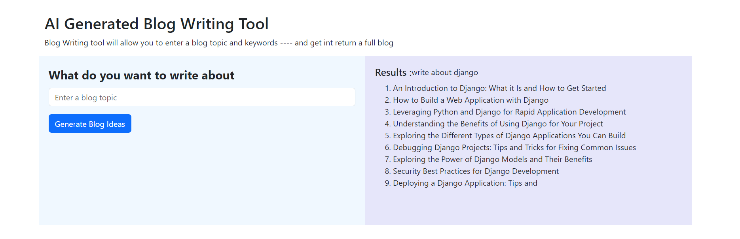

1. Generate blog sections:

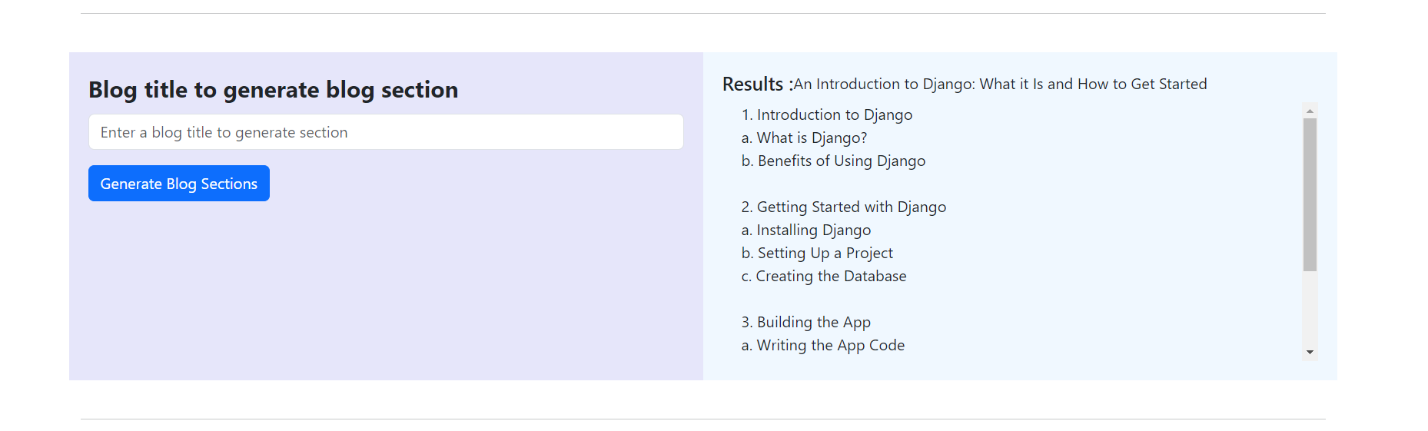

1. Generate content about section:

